Experiment - Git Conflict Resolution During Merge
Objective
Explain how to resolve the conflict during merge.
Implement conflict resolution when multiple users update the same file in different branches, resulting in a merge conflict.
Commands:
- Verify if Main is in Clean State
git checkout main
git status
- Create Branch "GitWork" and Add hello.xml
git checkout -b GitWork
notepad hello.xml
git status
git add hello.xml
git commit -m "Added hello.xml in GitWork"
- Update the Content of hello.xml and Observe Status
notepad hello.xml
git status
- Commit the Changes
git add hello.xml
git commit -m "Updated hello.xml in GitWork"
- Switch to Main
git checkout main
6. Add hello.xml in Main with Different Content
notepad hello.xml
git add hello.xml
git commit -m "Added hello.xml in main"
7. Commit the Changes to Main
git commit -m "Added hello.xml in main"
8. Observe the Commit Log
git log --oneline --graph --decorate --all
9. Check Differences
git diff main GitWork
10. Open P4Merge
If configured:
git difftool main GitWork
11. Merge GitWork into Main
git merge GitWork
12. Observe Git Conflict Markup
notepad hello.xml
You'll see:
<<<<<<< HEAD
<message>Hello from Main Branch</message>
=======
<message>Hello from GitWork Branch</message>
>>>>>>> GitWork
13. Resolve the Conflict
Edit hello.xml to:
<message>Hello from Main Branch</message>
<message>Hello from GitWork Branch</message>
Then:
git add hello.xml
git commit -m "Resolved merge conflict"

14. Commit After Resolving Conflict
Already done:
git commit -m "Resolved merge conflict"
15. Check Status and Update .gitignore
git status
notepad .gitignore
Add:
*.log
log/
Save.
16. Commit .gitignore
git add .gitignore
git commit -m "Updated .gitignore"
17. List All Branches
git branch
18. Delete the Merged Branch
git branch -d GitWork
19. Observe Final Commit Log
git log --oneline --graph –decorate
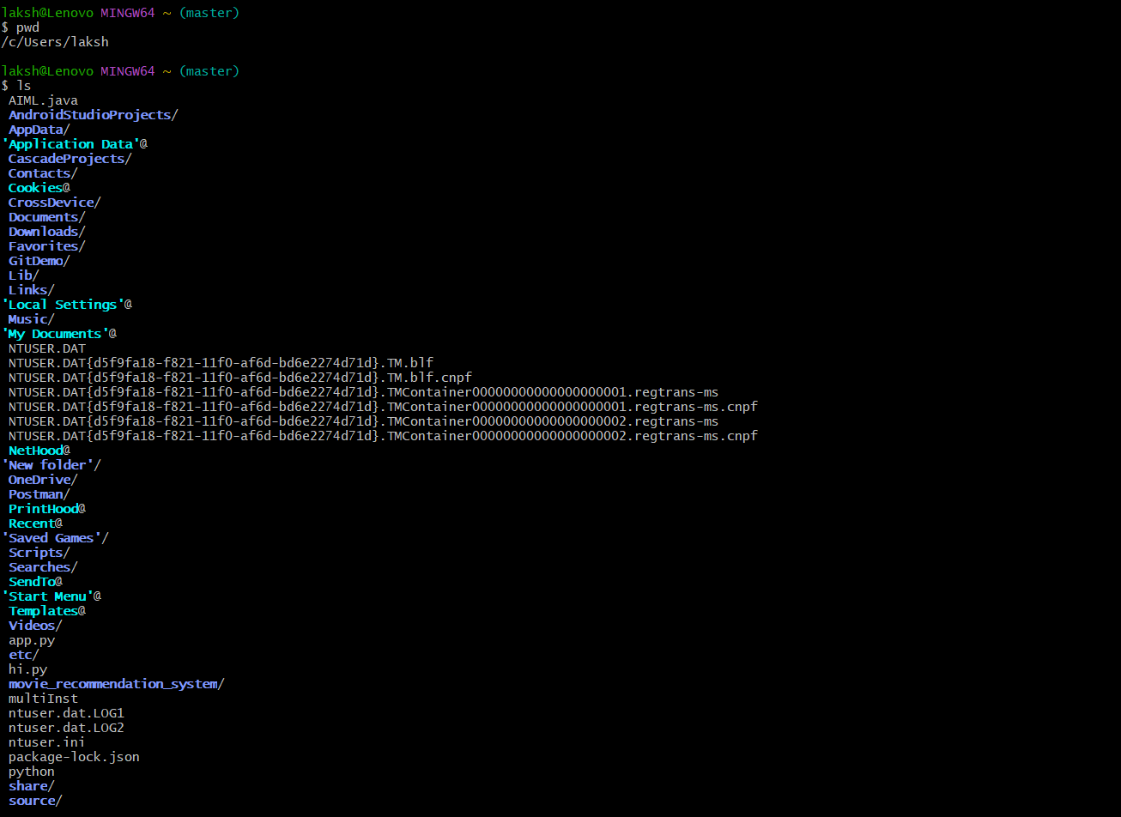
Outputs:
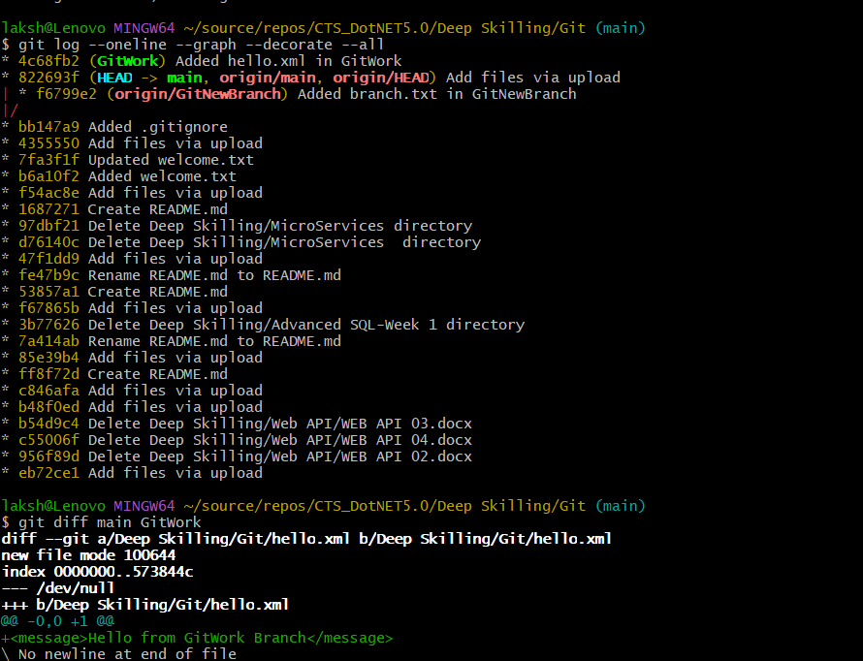
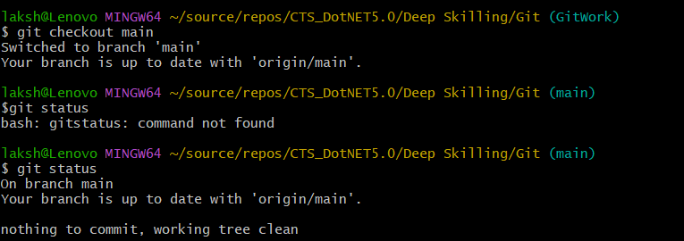
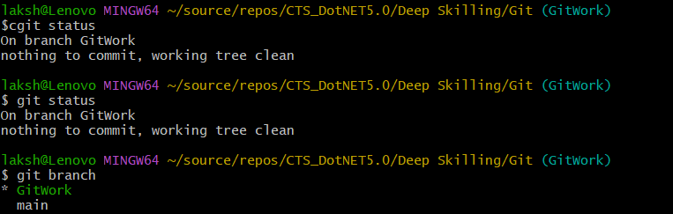
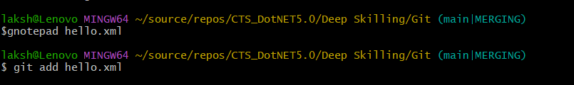
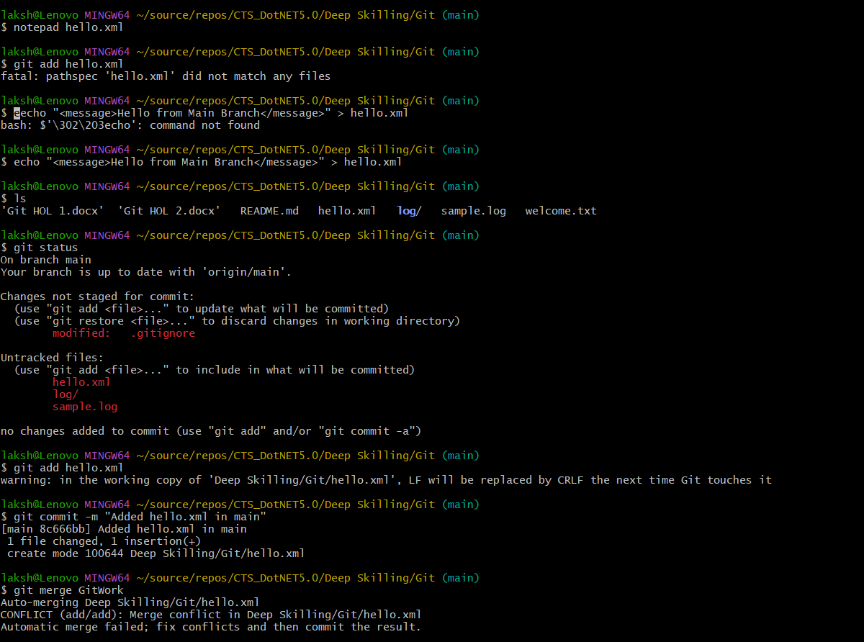
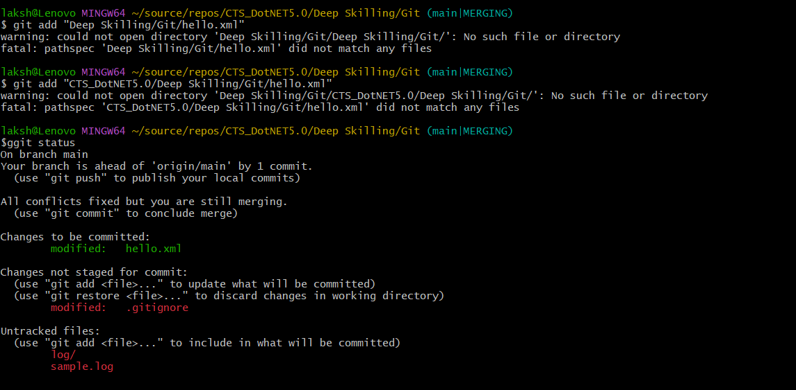

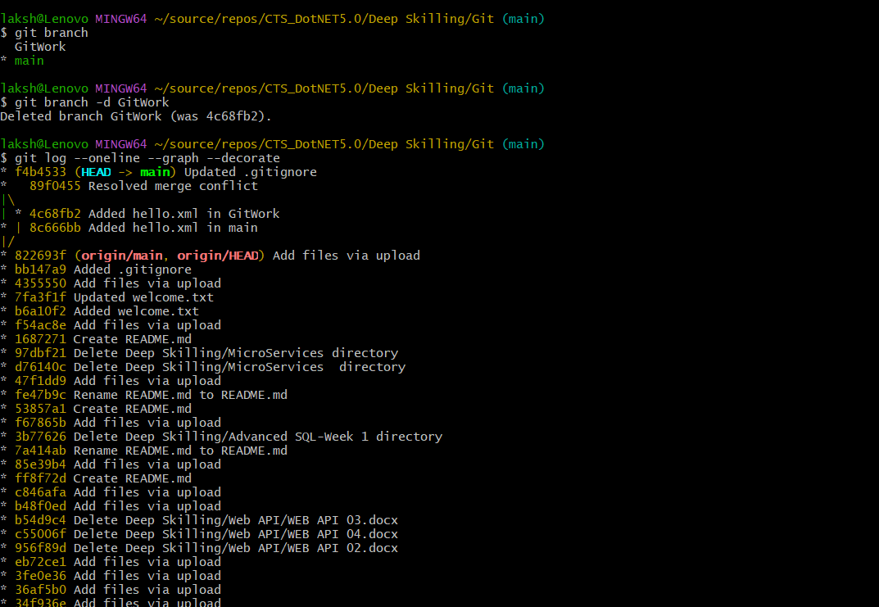
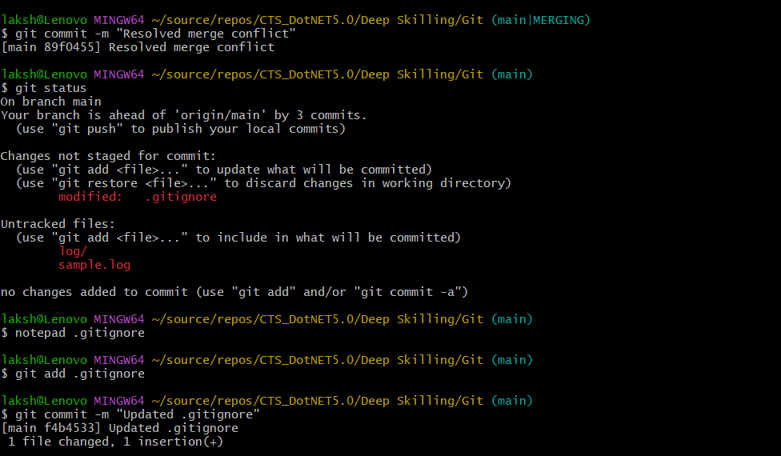

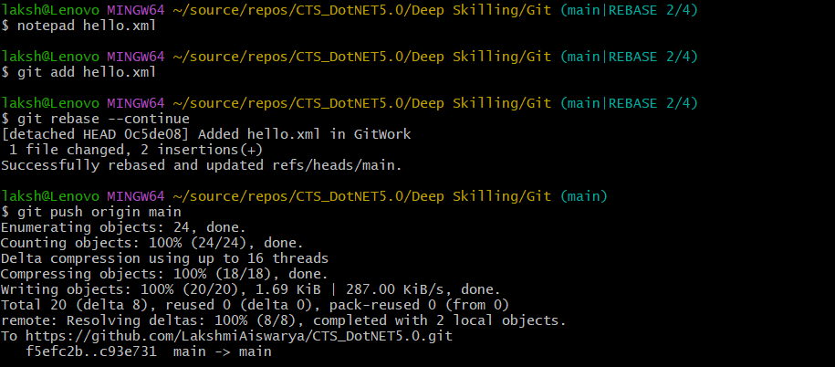
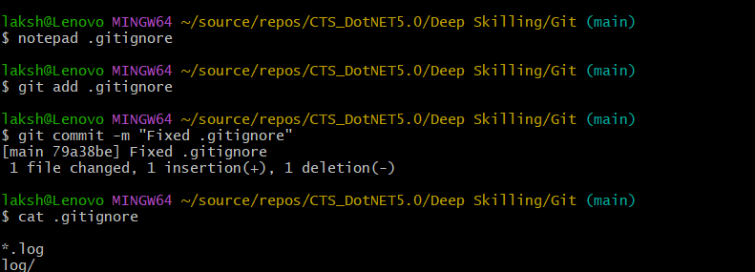

Result
The merge conflict between the main and GitWork branches was successfully created and resolved using Git. The conflicting changes in hello.xml were identified, resolved by editing the file, and committed successfully. The .gitignore file was updated, the merged branch was deleted, and the final commit history was verified using Git log.

